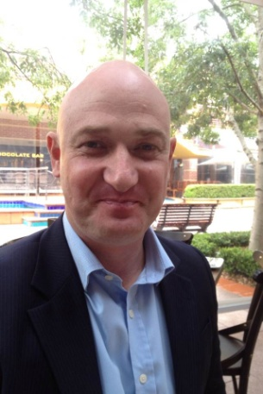
Update from the Community Coaching Program.
By Tony Briggs

The Community Coaching Programme has had a very successful year to-date Peter and Emily have prepared and presented to the Nature Conservation Council of Australia, I have presented to the NSW Cancer Council and all other team members are actively involved in assignments. The team has secured a working relationship with the NSW Centre for Volunteering who have regular contact with thousands of Not-for-Profit organisations to assist with attracting new organisations to benefit from our teams services.

The team is currently recruiting for enthusiastic, experienced PMP’s who want to “give back” to the community. Not only would you be assisting not-for-profit organisations who don’t have the funds available to secure highly professional resources as such as yourself. You will also be challenged to make a difference in the organisation that is sustainable.
If you are interested in volunteering for the Community Coaching Program, please send me a message.

